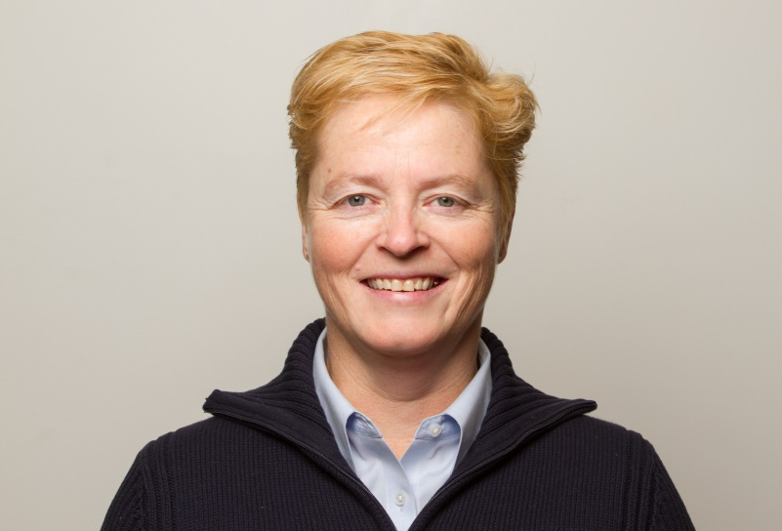

Shaleen Woodward

BIOGRAPHY

Principal Secretary
Executive and Indigenous Affairs
Shaleen spent many of her early years with the Government of the Northwest Territories focused on labour relations and equal pay. Shaleen received her first Premier’s Award of Excellence for work on the Equal Pay Team, including the negotiation of a resolution to a human rights complaint and overseeing payments. Shaleen has extensive experience in labour negotiations, acting as chief negotiator for the Union of Northern Workers and physician negotiations for a number of years.
Recognized as an effective change leader, Shaleen was recruited to lead System Reform and Innovation at the Department of Health and Social Services in 2009.
In 2011, Shaleen was recruited to lead the GNWT wide implementation of the historic 2014 devolution of responsibilities around land and resources, resulting in a second Premier’s Award.
Following devolution implementation, Shaleen moved to the Department of Aboriginal Affairs and Intergovernmental Relations (DAAIR) in 2014 where she took on the role of Assistant Deputy Minister. In 2015, Shaleen became acting Deputy Minister. Shaleen was most recently the Deputy Secretary of Indigenous and Intergovernmental Affairs, spanning the same responsibilities as the Deputy Minister of DAAIR.
Shaleen has been an active volunteer who has spent many years with Hockey Canada, including the development and delivery of Hockey Canada’s groundbreaking harassment, abuse and bullying prevention program Speak Out.

